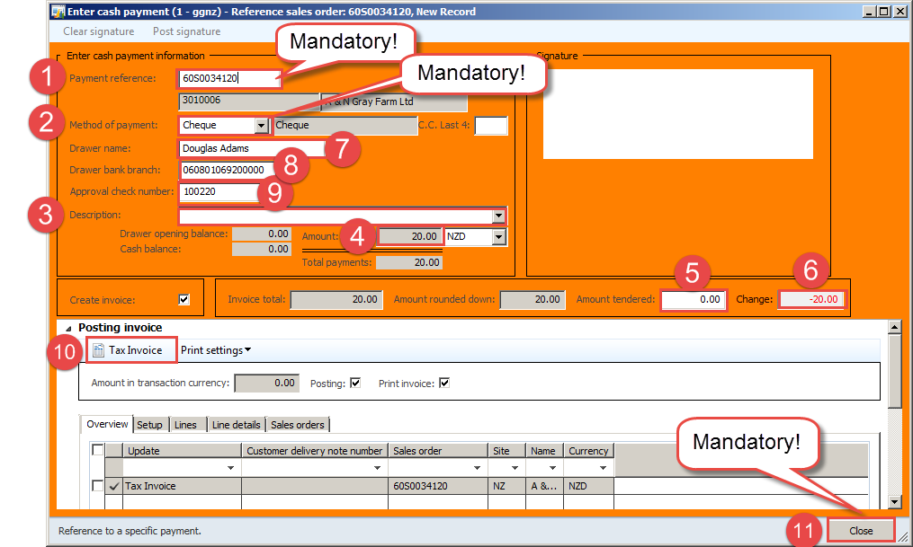**NAXT Quick tips**

**Filling in the cash sale screen - Cheques**

*From Sales order, go to Sell > Cash register > Cash register payment type*

Select the Payment type code and click OK.

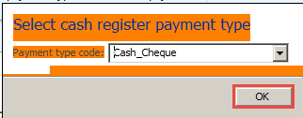

*Fill in Enter cash payment form:*

1. **Payment reference**: **Mandatory!** enter sales order number

* 60S0034120

1. **Method of payment: Mandatory!** This must match Payment type code

* Cheque

1. **Description: Enter reason if payment is being made in advance:**
2. **Amount: *(displays the amount customer should pay)*** e.g. $20.00
3. **Amount tendered: n/a**
4. **Change: n/a**

***Cheques only****:*

1. **Drawer name:** Type in name from cheque e.g. Douglas Adams
2. **Drawer bank branch:** Type in bank and branch from cheque - see digits below
3. C:\Users\JESSIC~1\AppData\Local\Temp\SNAGHTMLfad9c.PNG**Approval cheque number:** Type in cheque number – see digits below

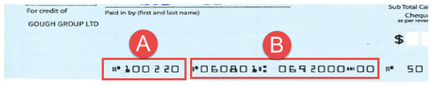

1. **Tax Invoice:** Press this button when you have finished filling in form.

* **Invoice** will print – branch must give this to the customer.
* **Banking journal will be created**

For more info see: ***FAR_2.12(SOP)Create and Manage a Banking Journal***

1. **Close: Mandatory!** You must press the **Close** button immediately or you’ll create unwanted extra work for accounts receivable staff.

If **Payment type code** does not equal **Method of payment**, do not press **Tax Invoice!** Press Close button and start again.

e.g. Cash_Cheque + EFTPOS = X

C:\Users\JESSIC~1\AppData\Local\Temp\SNAGHTML103024.PNGe.g. Cash_Cheque + Cheque = ☺

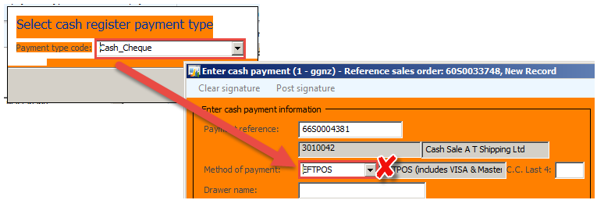

*For more info* see:

***PRT_2.1(SOP)Create and Manage a Cash Sales order***



Company policy is cheques must be banked within two days.